

# **EXERCICE DANS LA CUISINE DE LISA**

# **LA PRÉVENTION DES ACCIDENTS DOMESTIQUES CHEZ L’ENFANT- TP ADVF- CCP3**

Vous gardez Lisa, 2ans et demi, elle est seule dans la cuisine a votre arrivée.

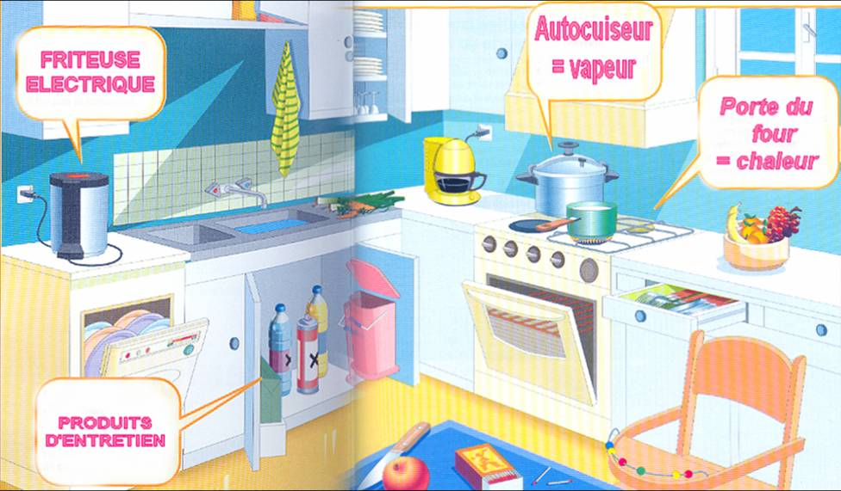

Source : <https://www.bing.com/search?q=dangers+de+la+cuisine&form=EDNTHT&mkt=fr-fr&httpsmsn>

Question : Lister les dangers que vous observez dans la cuisine de Lisa

1-………………………………………………………………………………………………………………………………………………………………………………………………………………………………………………………………………………………………………………………………………………………………………………

2-

………………………………………………………………………………………………………………………………………………………………………………………………………………………………………………………………………………………………………………………………………………………………………………

3-

………………………………………………………………………………………………………………………………………………………………………………………………………………………………………………………………………………………………………………………………………………………………………………

4-

………………………………………………………………………………………………………………………………………………………………………………………………………………………………………………………………………………………………………………………………………………………………………………

5-

………………………………………………………………………………………………………………………………………………………………………………………………………………………………………………………………………………………………………………………………………………………………………………

6-

………………………………………………………………………………………………………………………………………………………………………………………………………………………………………………………………………………………………………………………………………………………………………………

Quel est le rôle de l’ADVF dans cette situation ?

………………………………………………………………………………………………………………………………………………………………………………………………………………………………………………………………………………………………………………………………………………………………………………

………………………………………………………………………………………………………………………………………………………………………………………………………………………………………………………………………………………………………………………………………………………………………………

………………………………………………………………………………………………………………………………………………………………………………………………………………………………………………………………………………………………………………………………………………………………………………

………………………………………………………………………………………………………………………………………………………………………………………………………………………………………………………………………………………………………………………………………………………………………………

………………………………………………………………………………………………………………………………………………………………………………………………………………………………………………………………………………………………………………………………………………………………………………

………………………………………………………………………………………………………………………………………………………………………………………………………………………………………………………………………………………………………………………………………………………………………………

………………………………………………………………………………………………………………………………………………………………………………………………………………………………………………………………………………………………………………………………………………………………………………